Creating a .UDC file to download to PLC via UniDownLoader

- Open VisiLogic, with the program you want to load into the PLC via UniDownloader.

- Go to ‘Project’ > ‘Create Project File’ > Save the .vdf file in an appropriate folder with a related file name.
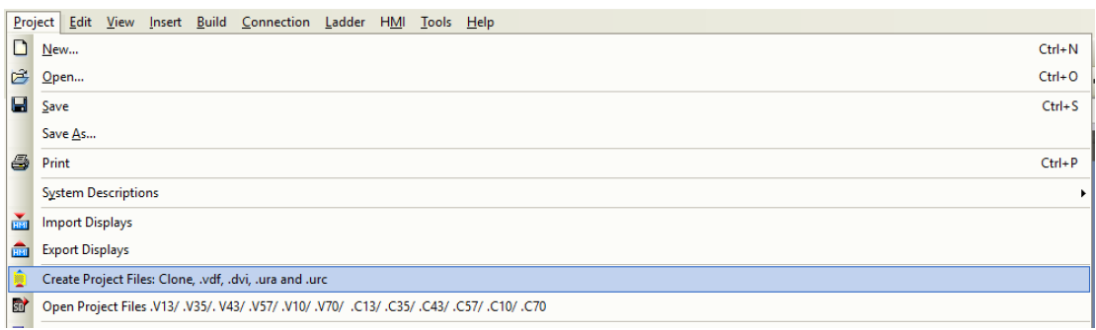

- In VisiLogic, go to ‘Tools’ > ‘UniDownload Designer’.
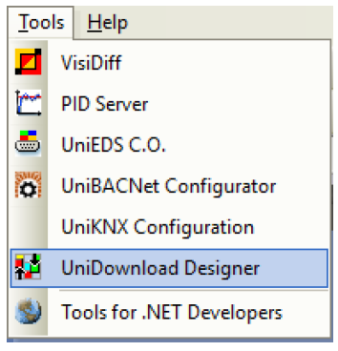

- A new pop-up window appears. In the field named ‘Application’ select the .vdf file you created previously.
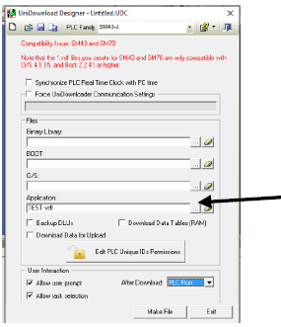

- Tick the appropriate boxes as per your requirements.
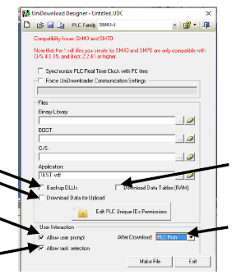

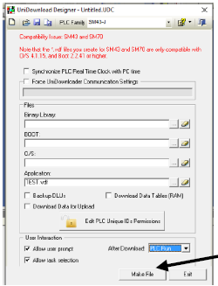
- Once an application is selected you can select ‘Make File’ in the bottom right.

- You will be prompted to give this new file a name, give it an appropriate name (probably related to the original Visilogic project file name) and save.
The program will build then save a new .udc file for use with UniDownloader.
Open your UniDownLoader software available from http://www.unitronics.guru/i4SoftwareUtilities.html and at the top left of the screen you can select the ‘Open Runner Design’ icon. This will bring up a file explorer which you can use to locate the .udc file you saved previously.
- Creating file to download to PLC via UniDownLoader
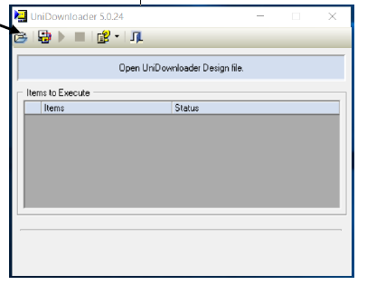

- Once you have opened your .udc file in UniDownLoader you can download this program to your PLC by hitting the ‘Run’ icon at the top of the screen.
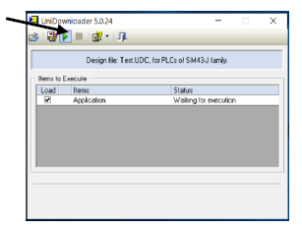

- You will be prompted to enter Communication setting before the download can begin, enter these as you would when communicating with a PLC in VisiLogic. Once these have been entered correctly and a communication between PC and PLC has been established the download will begin.
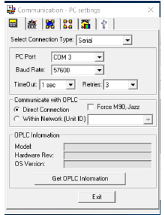

You will be prompted to give this new file a name, give it an appropriate name (probably related to the original Visilogic project file name) and save.
The program will build then save a new .udc file for use with UniDownloader
Open your UniDownLoader software available from http://www.unitronics.guru/i4SoftwareUtilities.html and at the top left of the screen you can select the ‘Open Runner Design’ icon. This will bring up a file explorer which you can use to locate the .udc file you saved previously. Telephone: 01480 395256 www.i4automation.co.uk sales@i4automation.co.uk Creating file to download to PLC via UniDownLoader

Once you have opened your .udc file in UniDownLoader you can download this program to your PLC by hitting the ‘Run’ icon at the top of the screen.
You will be prompted to enter Communication setting before the download can begin, enter these as you would when communicating with a PLC in VisiLogic. Once these have been entered correctly and a communication between PC and PLC has been established the download will begin.

