Overview
Unitronics UniStream controller has the capability to communicate EtherNet/IP, a popular Ethernet protocol. The UniStream can be configured as both Scanner (master) and Adapter (slave).
Many Allen Bradley products also support the EtherNet/IP protocol. Allen Bradley can be set to Scanner (master) only, this is a common limitation for PLCs.
This document will outline how to configure a UniStream as EtherNet/IP adapter in the UniLogic software. An Allen Bradley controller will be configured as a Scanner using the CompactLogix software. This will result in the Allen Bradley device communicating as a scanner to a UniStream Adapter.
To begin, start by configuring the UniStream as adapter using the steps below:
UniStream as Adapter
- Open the UniLogic software.
- The UniStream has 2 IP addresses, 1 for the Panel, the other for the CPU. Each IP address handles different tasks. UniStream will utilize the CPU IP address for EtherNet/IP communication. To set the CPU IP address, in the solution explorer navigate to Project > PLC Communication > Physical > CPU Ethernet. To the right, in the properties window, assign a unique IP address on the same network as the Allen Bradley PLC. This example will use 192.168.1.3 (Panel IP as default 192.168.1.2).
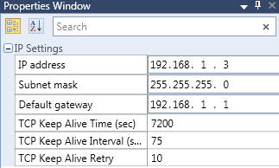
- To configure the UniStream as Adapter, in the solution explorer navigate to Project > PLC communications > Protocols > Ethernet IP > Adapter. Click Add New Adapter Node. Adapter Node1 will appear, shown below.
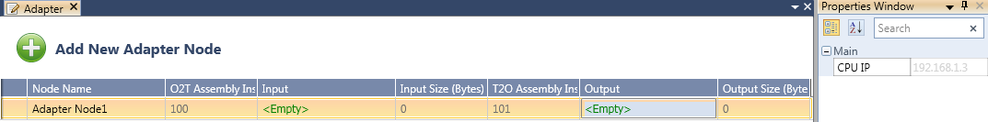
A quick overview of the information:
Node Name- This is the name of the node, and is for project reference only. It can be renamed.
O2T Assembly instance (Read only) - This is a pointer for the input information. It will be required when configuring the Allen Bradley PLC as a scanner.
Input- A tag is linked here. It can a single tag, an array of tags, or a struct (mixed data). This is the information received from the Allen Bradley. It must be whole bytes.
Input Size (read only) - Based on the tag linked under Input, the software will calculate the size of the information in Bytes. It will be required when configuring the Allen Bradley PLC as scanner.
T2O Assembly Instance (Read only) - This is a pointer for the output information. It will be required when configuring the Allen Bradley PLC as scanner. It will be required when configuring the Allen Bradley PLC as a scanner.
Output- A tag is linked here. It can be a single tag, an array of tags, or a struct (mixed data). This is the information sent to the Allen Bradley. It must be whole bytes.
Output Size (read only) - Based on the tag linked under output, the software will calculate the size of the information in Bytes. It will be required when configuring the Allen Bradley PLC as a scanner.
- Next, we will create the data tags that will be communicated. Step 4 will vary based on the system, and the information required to communicate. Create a tag for Input and Output. For this example, structs will be created. Navigate to the Tag Database > Structs. Click the add new tag icon in the top left corner.
  - Input Struct- For this example, name the struct EIP_Input_Struct. Add all information that the UniStream will accept from the Allen Bradley PLC. In this example, 2 arrays will be added (16 Bits, 5 Int16) totaling 12 bytes.
  - Output Struct- For this example, name the struct EIP_Output_Struct add all information that the UniStream will accept from the Allen Bradley PLC. In this example, 2 arrays will be added (16 Bits, 2 Int16) totaling 6 bytes.
Once complete, 2 new structs are available. These can be thought of as a new data type.
- To utilize a struct, create an instance. Navigate to the tag database > Global. Click the add new tag icon in the top left hand corner.
  - Input instance- For this example, name the tag EIP_input_Instance, and under type, select EIP_Input_Struct, shown below:
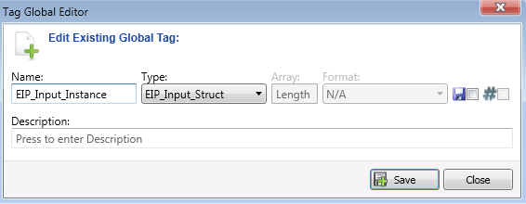

  - Output instance- For this example, name the tag EIP_Output_Instance, and under type, select EIP_Output_Struct, shown below:

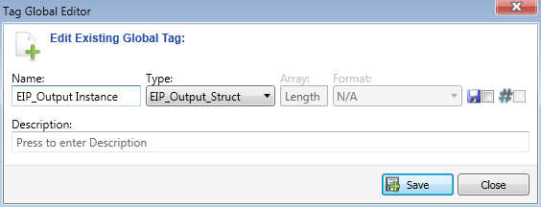

- Next, finish the Adapter setup. Navigate to the Solution explorer > PLC communications > Protocols > EtherNet/IP > Adapter. For Adapter Node1, link the output and input struct instances created in step 5. Result below:
Note that the Input size and Output size are automatically calculated. An important reminder, the tags linked must be in a whole bytes. As an example, if a single bit tag was linked, communication would fail.

Allen Bradley as Scanner
An EtherNet/IP scanner setup is dependent on the adapter. The adapter device must provide communication parameters to the scanner.
An EDS file is a file available or created by an adapter that outlines EIP communication parameters for the adapter. The UniStream does not work with EDS files. Instead, the communication parameters required will be available in the software. In the solution explorer, navigate to Project > PLC communication > Protocols > EtherNet/IP > Adapter. Information below:
The information required will be
O2T: 100
Input Size: 12
T2O: 101
Output Size: 6

Now, within CompactLogix, configure an Allen Bradley PLC for Scanner using the steps below:

1. Within CompactLogix, add a Generic Ethernet Module shown below.

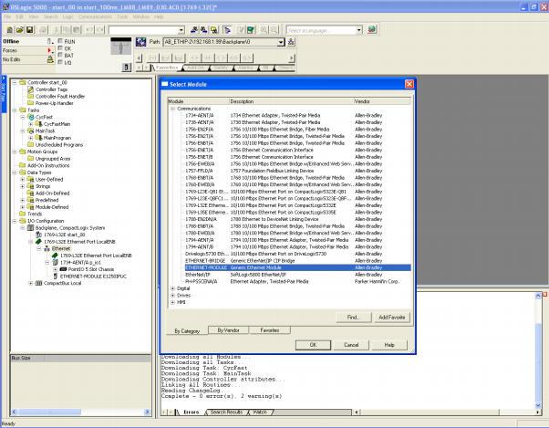

2. The following Module Properties menu will appear.
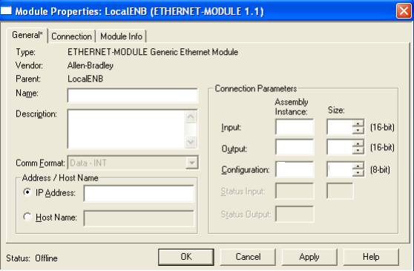
Enter information to match the information defined in the UniStream adapter settings. Below explains each parameter.
Name- application reference only
Comm Format- options for 8bit/16bit/32bit can be selected based on the project. For this example, Data-INT (16 bit) is selected.
IP Address- this is the IP address of the adapter, in this case, the UniStream CPU IP address will be used.
Assembly instances- Referencing the data pointers (O2T and T2O in the UniLogic setup).
Size- Referencing the Input/Output tags defined in the UniLogic setup.

The below setup matches the adapter settings.

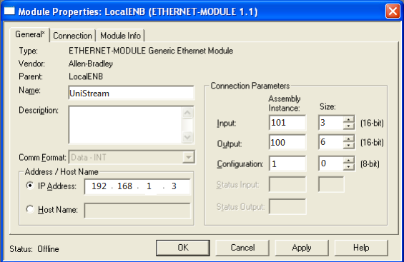

Notes:
- The T2O information is entered in the Inputs row. This means the tag linked in UniLogic under Outputs is mapped to inputs in compact Logix. Similarly, O2T (inputs in UniLogic) are mapped to Outputs in CompactLogix.
- The Size in UniLogic is represented in Bytes. In this example, Size is represented in words for inputs and outputs. Thus, the sizes in UniLogic must be halved before being entered in CompactLogix.
- The configuration does not exist within the UniLogic software. Still, there must be valid information entered for configuration within CompactLogix. An Assembly instance of 1, and a Size of 0 should be entered.

3. Next, navigate to the Connection Tab. Here, set the RPI (speed of communication in ms). Enter a value between 1.0 and 3200.0.
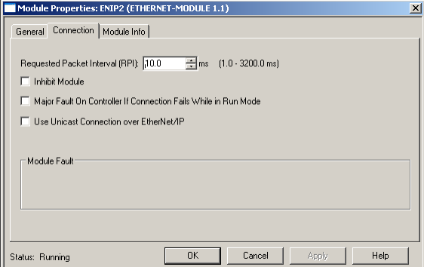

The Allen Bradley PLC is now configured as a scanner. Tags will appear in the CompactLogix as UniStream: I for inputs, and UniStream:0 for outputs.

